Common (Global) Coupling

📌 Definition:
# Source: AI Source: Provided by: [Data Path: Persons Table -> ID Column: 1, Name_En Column: Motasem Essam] -> From: [Chatgpt (GPT‑5 Mini)] on [12/9/2025]
Common (Global) Coupling occurs when multiple classes/modules share global data, so changes to the global data affect all modules that use it.

🧠 Simple idea:
# Source: AI Source: Provided by: [Data Path: Persons Table -> ID Column: 1, Name_En Column: Motasem Essam] -> From: [Chatgpt (GPT‑5 Mini)] on [12/9/2025]
“Everyone depends on the same global variable” ⚠️

🔍 Key characteristics:
# Source: AI Source: Provided by: [Data Path: Persons Table -> ID Column: 1, Name_En Column: Motasem Essam] -> From: [Chatgpt (GPT‑5 Mini)] on [12/9/2025]
- All modules depend on the same global variable
- ❌ Difficult to maintain and test
- ❌ Increases risk of unexpected side effects
- ❌ Reduces modularity and reusability

📊 Example of Common Coupling (Bad Practice):
# Source: AI Source: Provided by: [Data Path: Persons Table -> ID Column: 1, Name_En Column: Motasem Essam] -> From: [Chatgpt (GPT‑5 Mini)] on [12/9/2025]
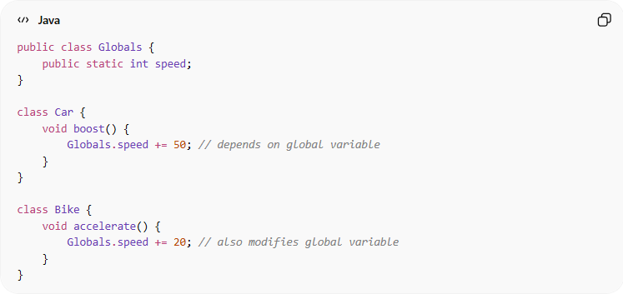
public class Globals {
public static int speed;
}

class Car {
void boost() {
Globals.speed += 50; // depends on global variable
}
}

class Bike {
void accelerate() {
Globals.speed += 20; // also modifies global variable
}
}
- ✅ Both Car and Bike depend on Globals.speed
- ✅ Changing Globals.speed in one module affects all others → high risk

🛡️ Avoiding Common Coupling Example:
# Source: AI Source: Provided by: [Data Path: Persons Table -> ID Column: 1, Name_En Column: Motasem Essam] -> From: [Chatgpt (GPT‑5 Mini)] on [12/9/2025]
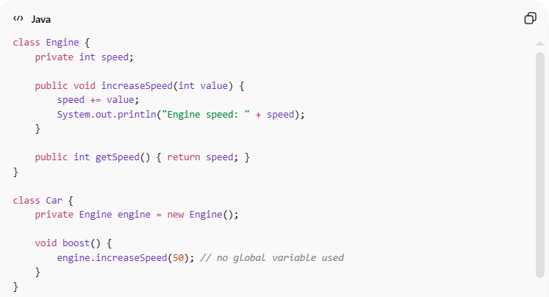
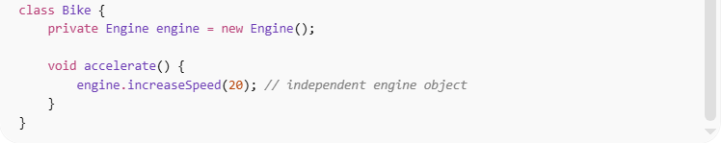
class Engine {
private int speed;

public void increaseSpeed(int value) {
speed += value;
System.out.println("Engine speed: " + speed);
}

public int getSpeed() { return speed; }
}

class Car {
private Engine engine = new Engine();

void boost() {
engine.increaseSpeed(50); // no global variable used
}
}

class Bike {
private Engine engine = new Engine();

void accelerate() {
engine.increaseSpeed(20); // independent engine object
}
}
✅ Key improvements:
- Each module/class uses its own data, no shared global variables
- Reduces unintended side effects
- Improves modularity, encapsulation, and maintainability

⚙️ Best Practice:
# Source: AI Source: Provided by: [Data Path: Persons Table -> ID Column: 1, Name_En Column: Motasem Essam] -> From: [Chatgpt (GPT‑5 Mini)] on [12/9/2025]
- Avoid global variables wherever possible
- Use private data inside classes
- Apply encapsulation and dependency injection
- Ensure each module works independently to reduce side effects

